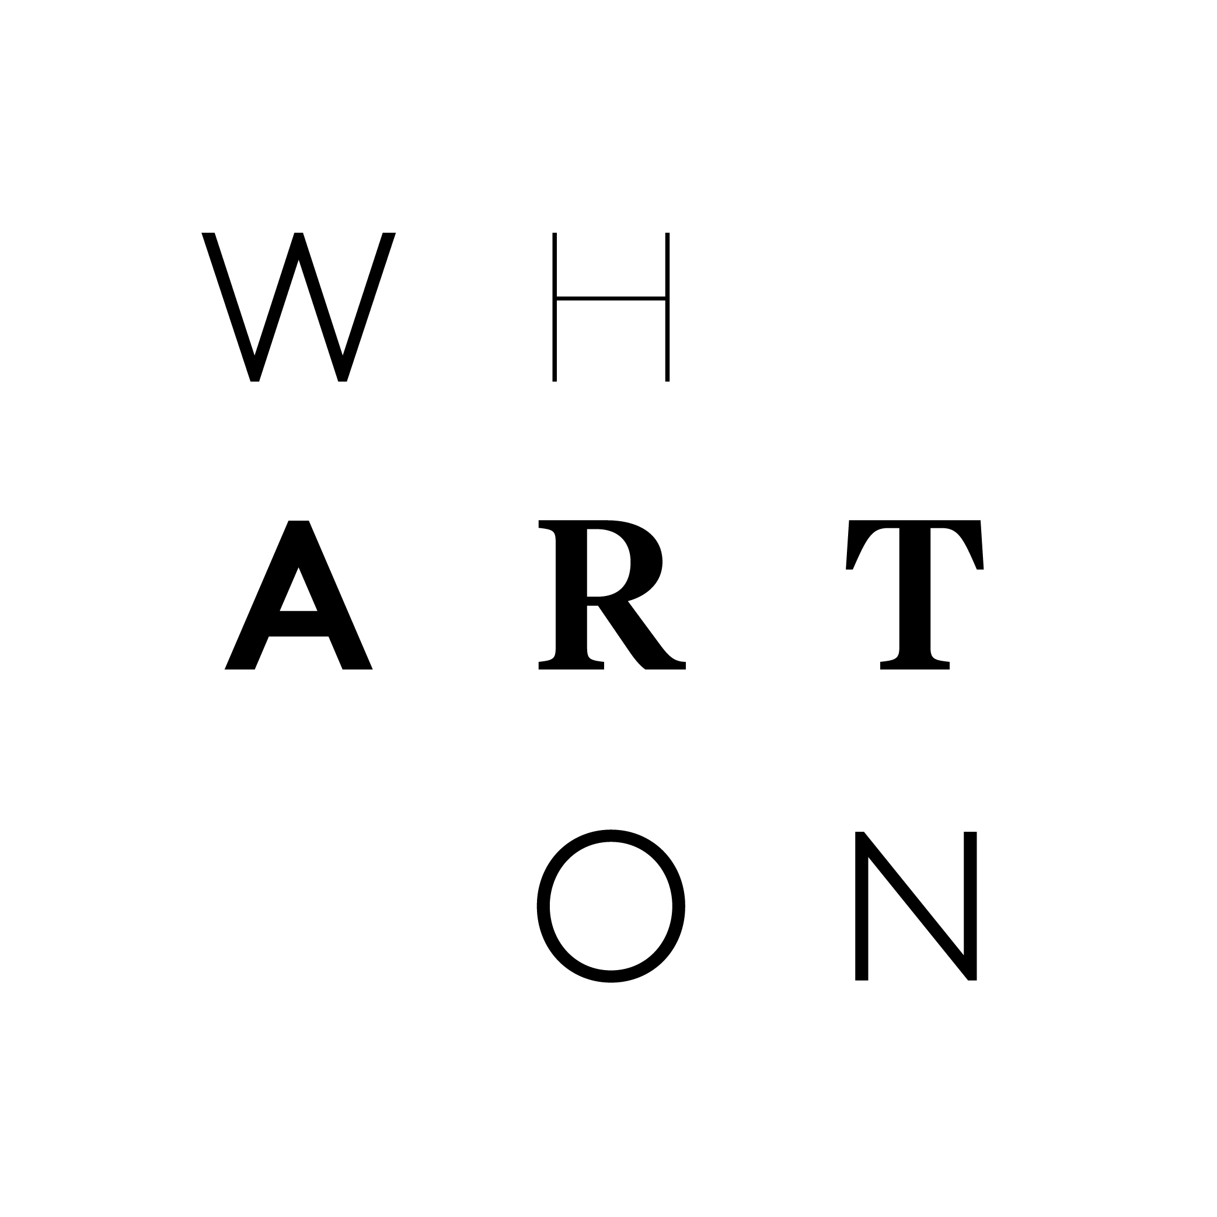
WHARTON CENTER ANNOUNCES

THE 2024-2025 BROADWAY SEASON

MEDIA EMBARGO UNTIL MONDAY, MARCH 4

EAST LANSING, MI — It’s one of the most anticipated times of the year at Wharton Center; the announcement of the new Broadway Series! Tickets can be purchased as part of a subscription package starting Monday, March 4, at 9AM. The five-show Broadway Series package begins at just $225.

WHARTON CENTER’S 2024-2025 BROADWAY SERIES:

Les Misérables
October 8–13, 2024

Shucked
January 21–26, 2025

MJ
February 11–16, 2025

Life of Pi
March 11–16, 2025

Chicago
April 8-13, 2025

6-show Package includes:

Hamilton
May 21-June 1, 2025
May 21- 27, 2025 – Subscription Week

Add-on Event

The Book of Mormon
June 19–22, 2025

“As we announce the 2024-2025 Broadway Series, I'm bursting with excitement!" exclaims Executive Director Eric Olmscheid. “This upcoming Broadway season has something for everyone and promises to be an absolute delight. We are honored to host the Michigan premieres of Shucked and Life of Pi as well as the Wharton Center premiere of MJ.”

The Broadway at Wharton Center Series, supported by MSU Federal Credit Union, begins October 8–13, 2024, with Cameron Mackintosh’s acclaimed production of Alain Boublil and Claude-Michel Schönberg’s Tony Award® winning musical phenomenon, LES MISÉRABLES. The brilliant staging of this show has taken the world by storm and has been hailed as ‘Les Mis for the 21st Century” (Huffington Post), and “one of the greatest musicals ever created” (Chicago Tribune). Set against the backdrop of 19th century France, LES MISÉRABLES tells an enthralling story of broken dreams and unrequited love, passion, sacrifice, and redemption: a timeless testament to the survival of the human spirit. This epic and uplifting story has become one of the most celebrated musicals in theatrical history. Last at Wharton Center in 2019.

January 21–26, 2025, brings the Tony Award® winning musical comedy SHUCKED which The Wall Street Journal calls “flat out hilarious!” to Wharton Center for its Michigan premiere. Featuring a book by Tony Award® winner Robert Horn (Tootsie), a score by the Grammy Award-winning songwriting team of Brandy Clark and Shane McAnally and directed by Tony Award® winner Jack O’Brien (Hairspray), this corn-fed, corn-bred American musical is sure to satisfy your appetite for great musical theater.

The unparalleled artistry of the greatest entertainer of all time comes to East Lansing from February 11–16, 2025, as MJ, the multi–Tony Award® winning new musical centered around the making of the 1992 Dangerous World Tour, begins a tour of its own. Created by Tony Award® winning Director/Choreographer Christopher Wheeldon and two-time Pulitzer Prize winner Lynn Nottage, MJ goes beyond the singular moves and signature sound of the star, offering a rare look at the creative mind and collaborative spirit that catapulted Michael Jackson into legendary status. MJ is startin’ somethin’ as it makes its Wharton Center premiere.

The three-time Tony Award® winner and the Olivier Award for Best Play, LIFE OF PI makes its Michigan and Wharton Center premiere from March 11–16, 2025. It’s “an exhilarating evening of theater” (The Wall Street Journal). Based on the novel that sold more than 15 million copies and became a worldwide phenomenon, LIFE OF PI is an epic story of perseverance and hope that speaks to every generation and “gives new life to Broadway” (The Today Show). After a shipwreck in the middle of the Pacific Ocean, a sixteen-year-old boy named Pi survives on a lifeboat with four companions: a hyena, a zebra, an orangutan, and a Royal Bengal tiger. Told with jaw-dropping visuals, world class puppetry, and exquisite stagecraft, LIFE OF PI creates a breathtaking journey that will leave you filled with awe and joy.

The Tony Award® winning musical CHICAGO returns to Wharton Center after 14 years—in its 25th anniversary season—from April 8–13, 2025. CHICAGO is still the one musical with everything that makes Broadway shimmy-shake: a universal tale of fame, fortune, and all that jazz, with one showstopping song after another and the most astonishing dancing you’ve ever seen. No wonder CHICAGO has been honored with 6 Tony Awards®, 2 Olivier Awards, a Grammy, and thousands of standing ovations. You’ve got to come see why the name on everyone’s lips is still … CHICAGO.

HAMILTON is making its return from May 21 – June 1, 2025. A revolutionary story of passion, unstoppable ambition, and the dawn of a new nation. HAMILTON is the epic saga that follows the rise of Founding Father Alexander Hamilton as he fights for honor, love, and a legacy that would shape the course of a nation. Based on Ron Chernow’s acclaimed biography and set to a score that blends hip-hop, jazz, R&B, and Broadway, HAMILTON has had a profound impact on culture, politics, and education.

HAMILTON features a book, music, and lyrics by Lin-Manuel Miranda, direction by Thomas Kail, choreography by Andy Blankenbuehler, and musical supervision and orchestrations by Alex Lacamoire. In addition to its 11 Tony Awards®, it has won Grammy, Olivier Awards, the Pulitzer Prize for Drama, and an unprecedented special citation from the Kennedy Center Honors.

THE BOOK OF MORMON returns to Wharton Center from June 19–22, 2025, after 9 years. The New York Times calls it “the best musical of this century.” The Washington Post says, “It is the kind of evening that restores your faith in musicals.” And Entertainment Weekly says, “Grade A: the funniest musical of all time.” Jimmy Fallon of The Tonight Show calls it “Genius. Brilliant. Phenomenal.” It’s THE BOOK OF MORMON, the nine-time Tony Award® winning Best Musical. This outrageous musical comedy follows the adventures of a mismatched pair of missionaries, sent halfway across the world to spread the Good Word. With standing room only productions in London, on Broadway, and across North America, THE BOOK OF MORMON has truly become an international sensation.

Broadway subscription sales begin Monday, March 4.

The entire 2024–2025 Broadway Series can be found at whartonseason.com.

# # #
For high-resolution images from Wharton Center’s 2024–2025 season, visit whartoncentermedia.com.

